Library Management System
Project Synopsis
Version 2.3.0
Major Project (ICI651)
BCA (CTIS)
BACHELOR OF COMPUTER APPLICATION
(Cloud Technology and Information Security)

PROJECT GUIDE:  Mr. Aatish Kumar Baitha  Mr. Umesh Chandra Garjola | SUBMITTED BY:  Deepak Saini ( TCA2256018 )  Aryansh ( TCA2256014 )  Gaurav Chaubey ( TCA2256025 )  Hitesh Kumar ( TCA2256031 )

April, 2025


FACULTY OF ENGINEERING & COMPUTING SCIENCES
TEERTHANKER MAHAVEER UNIVERSITY, MORADABAD
Table of Contents

1 Project Title 4
2 Domain 4
3 Problem Statement 4
4 Project Description 5
4.1 Scope of the Work 5
4.2 Project Modules 5
4.3 Context Diagram (High Level) 7
5 Implementation Methodology 8
5.1.1 Development Approach 8
5.1.2 Data Flow Diagram (DFD) 8
5.1.3 Entity-Relationship (ER) Diagram 9
5.1.4 Use Case Diagram 10
5.1.5 Testing Strategy 11
6 Technologies to be used 12
6.1 Software Platform 12
6.2 Hardware Platform 12
6.3 Tools 13
7 Advantages of this Project 14
7.1.1 Time-Saving and Efficient 14
7.1.2 Accuracy and Error Reduction 14
7.1.3 Easy Book and Member Management 14
7.1.4 QR Code Integration 14
7.1.5 Real-Time Tracking and Notifications 14
7.1.6 User-Friendly Interface 15
7.1.7 Secure and Role-Based Access 15
7.1.8 Cost-Effective and Scalable 15
7.1.9 Portable and Lightweight 15
7.1.10 Maintains Historical Records 15
8 Future Scope and further enhancement of the Project 16
8.1.1 Web-Based Interface 16
8.1.2 Cloud Integration 16
8.1.3 SMS / Email Notification System 16
8.1.4 Barcode and RFID Integration 16
8.1.5 Role Management and User Permissions 16
8.1.6 Analytics and Reporting 17
8.1.7 Mobile App Development 17
8.1.8 8. Book Reservation and Renewal System 17
8.1.9 Digital Library Support 17
8.1.10 Admin Dashboard Enhancements 17
9 Team Details 18
10 Conclusion 18
11 References 19

Project Title
Library Management System

Domain
Software Application Development

Problem Statement
The Library Management System (LMS) is an essential solution developed to modernize and simplify the traditional management of library operations. Libraries have always been a core component of academic institutions, supporting education, research, and self-learning. However, managing a library manually becomes increasingly complex as the volume of books and users grows. Tasks such as maintaining book inventories, tracking issued and returned books, managing student records, and calculating fines can be time-consuming and error-prone when done manually.
To overcome these challenges, the topic of a Smart Library Management System using Python was chosen. The key motivation behind selecting this project is the increasing demand for digitization and automation in educational environments. The project aims to provide an efficient, reliable, and user-friendly solution that can assist librarians in managing library operations more effectively while offering students an easier way to access and use library resources.
This system introduces smart features like QR code scanning, automated book issue/return systems, and user authentication, making the system secure, fast, and scalable. The QR code functionality reduces the time taken to search and update records manually, thus improving operational efficiency. Additionally, real-time book status updates, fine calculation, and role-based access provide a professional and practical user experience.
By implementing this system, the burden on library staff is significantly reduced, human errors are minimized, and overall efficiency and accuracy are greatly improved. The system is adaptable for various library setups—whether it’s a school, college, or public library—and can be extended with features like cloud support or web access in the future.

Project Description
This section describes the scope, structure, and modules of the Smart Library Management System project. It also presents a high-level context diagram to understand the flow of data in and out of the system.

Scope of the Work
The Smart Library Management System is designed to automate core library operations such as book management, issuing and returning of books, and student record handling. The system ensures error-free, fast, and efficient management of library functions by providing a role-based user interface.

In-Scope:
- Adding, updating, and deleting book records
- Issuing and returning books with due dates
- Viewing student-wise book history
- Generating and scanning QR codes for books
- Viewing available and issued books
- Admin and student role-based panels
- GUI-based interface using Tkinter
- Local database connection using SQLite

Out of Scope:
- Online/cloud-based access and hosting
- Integration with external library APIs or systems
- Automatic SMS/email notifications
- Inventory for physical book stock checking
- E-book reader integration or download features

Project Modules
Each module in the project is developed to perform a specific task, making the system modular and maintainable. Below are the key modules and their functions:

Main Menu & Navigation
- Acts as the central hub for users after login.
- Based on user role (Admin or Student), directs to the respective panel.
- Provides access to major features through buttons or menus.

Admin Panel (admin_panel.py)
- Add new books to the library with details like title, author, and ID.
- Delete or update existing books.
- Issue books to registered students with return date.
- Accept book returns and auto-calculate fines.
- Generate and manage QR codes for books.
- View list of all books and their statuses.
- View list of registered students and their book activities.

Student Panel (Student_panel.py)
- Allows students to check their currently issued books.
- View due dates and book availability.
- Scan QR codes to check details of books.
- Navigate through a simplified UI built for student interaction.

Book Management Module
- Add Book (Add_book.py): Adds new books into the database.
- Delete Book (Delet_book.py): Deletes existing book entries.
- Issue Book (Issue_book.py): Assigns a book to a student, with timestamp and expected return.
- Return Book (Return_book.py): Updates book status to “available” and calculates fine if overdue.

QR Code Module (G_QR.py)
- Generates QR codes for books to speed up scanning and issue/return operations.
- Improves user experience and reduces human error in tracking books.

Database Connection Module (Connect_DB.py)
- Establishes connection with the SQLite database.
- Executes SQL queries for data insertion, retrieval, and updates.

Media and Alerts
- beep.mp3: Plays a sound when a QR code is scanned or an operation is completed.
- lib.jpg: Used as a background or logo image in the interface.

Context Diagram (High Level)
At Level 0, the context diagram defines the interaction between the user and the system, showing all inputs and outputs.

External Entities:
- Admin
- Student

Inputs from Admin:
- Add/Edit/Delete Book Records
- Issue/Return Book Entries
- Generate QR Codes
- View Book and Student Reports

Outputs to Admin:
- Book Issue Confirmation
- Return Status and Fine
- QR Code Display
- Admin Dashboards and Reports

Inputs from Student:
- View Issued Books
- Check Book Availability
- Scan Book QR Code
- Return Book Request

Outputs to Student:
- Book Details
- Book Availability Status
- Student Panel Overview

Implementation Methodology
The implementation of the Library Management System was carried out in a structured and systematic manner, ensuring that all key functionalities were developed and tested effectively. The major steps followed in the software development process are outlined below:

Development Approach
We followed the Waterfall Model of software development, which included the following phases:
- Requirement Analysis: Identifying the key functionalities such as book management, student records, issue/return management.
- System Design: Designing the database schema and UI wireframes.
- Implementation: Coding the frontend using Tkinter (Python GUI) and the backend using MySQL.
- Testing: Unit and system testing were performed.
- Deployment: The system was deployed on a local machine for demonstration.
- Maintenance: A defect log was maintained to record bugs and enhancements.

Data Flow Diagram (DFD)
- Level 0 DFD: Depicts the main module “Library System” interacting with the Users and Database.
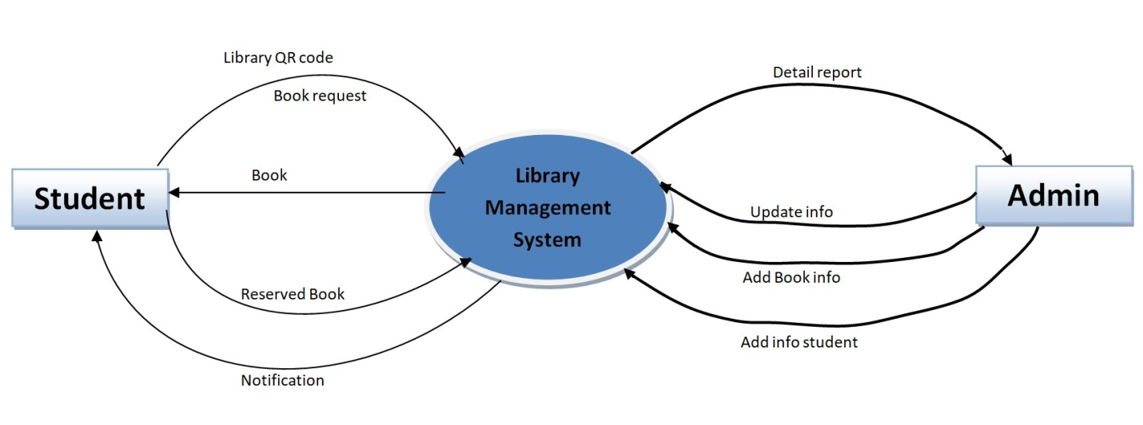
- Level 1 DFD: Shows sub-processes like:
  - Add/View/Delete Books
  - Issue/Return Book
  - Manage Student Records

Entity-Relationship (ER) Diagram
The ER Diagram shows the relationship between:
- Books, Students, and Transactions
- Relationships include:
  - One-to-Many: A student can issue multiple books.
  - One-to-One: A transaction is uniquely linked to a book and student.
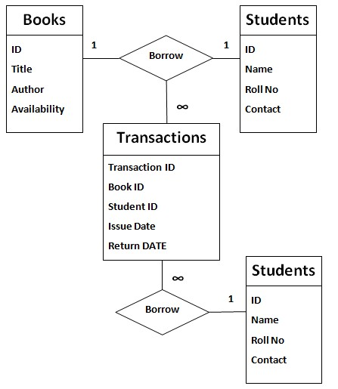

Use Case Diagram
Key use cases:
- Admin logs in
- Admin adds/updates/deletes books
- Admin adds/view student details
- Admin issues/returns books
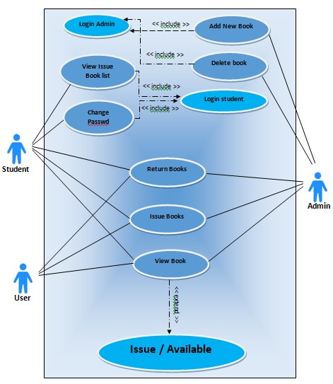

Testing Strategy
We followed the following testing techniques:
- Unit Testing: Tested each module separately (e.g., add book, issue book).
- Integration Testing: Verified data flow between modules.
- System Testing: Ensured the full application behaves as expected.
Defect Log Maintenance: A simple Excel sheet was used to record:
- Bug description
- Steps to reproduce
- Severity
- Status (Open/Closed)
- Resolution notes

Technologies to be used
This section highlights the software and hardware platforms, along with tools used during the development of the Smart Library Management System. The project leverages lightweight technologies for fast, local execution and simplified development.

Software Platform

- Front-end

• Technology Used: Python Tkinter Library
• Purpose: Used to create the Graphical User Interface (GUI) for Admin and Student panels. Provides buttons, labels, text fields, pop-up messages, and window navigation.

- Back-end

• Technology Used: Python + SQLite
• Purpose: Python acts as the core logic engine that processes all business logic such as book issue, return, fine calculation, QR generation, etc. SQLite is used as the embedded database to store persistent data such as book records, user data, and issue history.

Hardware Platform

Component | Specification
RAM | Minimum 4 GB (Recommended 8 GB)
Hard Disk | Minimum 100 MB free space
Processor | Intel Core i3 or higher
Operating System | Windows 10/11 or Linux (Ubuntu preferred)
Code Editor | Visual Studio Code (VS Code)
Python Version | Python 3.9 or above
Database | SQLite (built-in with Python)
Browser | Not required (project is desktop-based)

Tools
The following tools were used during various phases of the software development life cycle:
Tool Name | Vendor Name | Version | Purpose of Use
Visual Studio Code | Microsoft | 1.88 | Source code writing, file management, debugging
DB Browser for SQLite | DB Browser Team | 3.12.2 | Visual management and testing of SQLite database
Python | Python Software | 3.11 | Core programming language used

Advantages of this Project
The Smart Library Management System offers several advantages over traditional manual systems. It automates core library functions, improves efficiency, and enhances user experience for both librarians and students. Key benefits are listed below:

Time-Saving and Efficient
- Automates repetitive tasks such as book issuing, returning, and record maintenance.
- Reduces time spent on manual log entries and physical searches for book data.

Accuracy and Error Reduction
- Reduces human errors such as incorrect book entries, miscalculations in fines, or record mismatches.
- Ensures accurate tracking of borrow and return dates.

Easy Book and Member Management
- Simplifies management of book inventory, student details, and transaction logs.
- Allows easy editing, deletion, or searching of records via an intuitive GUI.

QR Code Integration
- Quick and efficient way to identify and issue/return books using QR codes.
- Minimizes the chances of issuing wrong books and speeds up the transaction process.

Real-Time Tracking and Notifications
- Enables real-time updates of issued books and due dates.
- Can be enhanced to provide reminders for due/overdue books.

User-Friendly Interface
- The GUI created using Tkinter is simple, clear, and easy to navigate for both Admins and Students.
- Provides a structured layout for smooth operations.

Secure and Role-Based Access
- Access is role-based to ensure only authorized users (Admin/Student) can perform specific actions.
- Prevents misuse or unauthorized access to the database.

Cost-Effective and Scalable
- Built using open-source tools like Python and SQLite, requiring no licensing cost.
- Scalable for future additions like online access, web deployment, or cloud integration.

Portable and Lightweight
- Requires minimal hardware resources.
- Can run on any standard computer system without requiring a dedicated server.

Maintains Historical Records
- Automatically stores records of issued/returned books for future references and reporting.
- Helps librarians analyze usage patterns and make informed purchasing decisions.

Future Scope and further enhancement of the Project
The Smart Library Management System is currently designed as a desktop-based solution using Python and SQLite for small to medium-sized libraries. While it effectively addresses the basic requirements of managing library resources, there is significant potential for expanding its functionality and usability in the future. Below are some key areas where this project can be enhanced:

Web-Based Interface
- Convert the system into a web application using Flask or Django to allow access from any device through a browser.
- Enable multi-user access over a network, making it ideal for large institutions.

Cloud Integration
- Store data on cloud platforms such as AWS or Firebase to improve accessibility, backup, and scalability.
- Facilitate real-time synchronization between multiple library branches.

SMS / Email Notification System
- Integrate an automated email/SMS reminder system to notify students about due dates, overdue fines, and book availability.

Barcode and RFID Integration
- Extend the current QR-based system to Barcode or RFID for faster and more secure book tracking and circulation.

Role Management and User Permissions
- Add more user roles like Librarian Assistants, Teachers, or External Members with specific access levels and privileges.

Analytics and Reporting
- Integrate data analytics for librarians to analyze book usage trends, top borrowed books, student engagement, and inventory requirements.
- Enable graphical reports for decision-making.

Mobile App Development
- Develop a companion mobile application to allow users to search books, check availability, and reserve books on the go.

8. Book Reservation and Renewal System
- Allow students to reserve books in advance and renew issued books via the system interface, minimizing in-person visits.

Digital Library Support
- Add modules for managing eBooks, PDFs, and online journals that users can access from their accounts.

Admin Dashboard Enhancements
- Add features like calendar integration, notifications dashboard, fine adjustment, and customizable settings for improved control.

Team Details

Project Name & ID | Course Name | Student ID | Student Name | Role | Signature
Library Management System | Bachelor of computer applications ( Cloud Technology and Information Security ) | TCA2256018 | Deepak saini | Developer
 |  | TCA2256025 | Gaurav chaubey | Testing/Quality Assurance
 |  | TCA2256014 | Aryansh | Database Administrator
 |  | TCA2256031 | Hitesh kumar | Maintainer

Conclusion
The development of the Library Management System successfully addresses the core challenges faced in managing traditional libraries, such as manual tracking, data inconsistency, and inefficient resource utilization. By automating key processes like book issuance, returns, catalog management, and fine calculation, the system improves accuracy, reduces manual workload, and enhances the overall user experience for both librarians and members.
This project demonstrates a practical and scalable solution that can be adapted for school, college, and public libraries. Its structured design, modular architecture, and user-friendly interface make it a sustainable and manageable solution for long-term use.
From a financial and operational perspective, the system minimizes dependency on manual resources and optimizes staff productivity, offering cost-effective benefits. Being developed in Python with easily maintainable code, the project can be extended or customized in the future based on evolving requirements.
In conclusion, implementing this system not only fulfills the academic objectives of the project but also provides a foundation for digital transformation in library operations. Future enhancements and integration with technologies like cloud storage, mobile applications, and AI-based recommendations can further increase its impact and usability.

References
This section provides a complete list of all documents and resources referenced throughout the Software Requirements Specification (SRS) and project documentation. These references serve as a basis for understanding system design, development, and testing standards.

S# | Reference Details | Owner | URLs
 | Python 3.10 Documentation | Python Software Foundation | https://docs.python.org/3/
 | SQLite Documentation | SQLite.org | https://www.sqlite.org/docs.html
 | geeksforgeeks | Geeksforgeeks.org | https://www.geeksforgeeks.org/python-programming-language-tutorial/

Home Page:
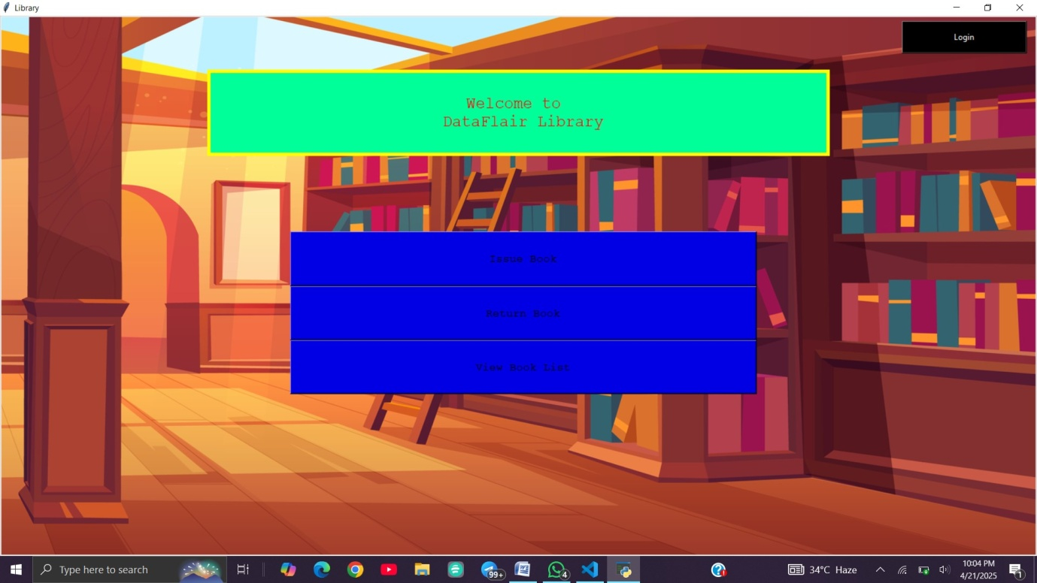

Student Change Password :
Admin and Student Login :

Admin Interface :

View Books :

Add new Books :

Delete Books :

Student InterFace :

Issue Books by Student:

